1. **Introduction:**

Plant diversity refers to the variety of plant species found in a particular area. Plants play a vital role in any habitat, providing structure, food, and shelter, and thus significantly contributing to the overall biodiversity of an ecosystem. This diversity includes everything from herbs, shrubs, and trees to mosses, liverworts, hornworts (Bryophytes), ferns (Pteridophytes), and a wide range of flowering plants. Plant diversity not only involves the number of different species but also the variation within them. Plants have an incredible ability to adapt to various environmental conditions—whether it's temperature extremes, soil types, light availability, altitude, or interactions with other organisms. These adaptations allow them to thrive across different parts of the world, often competing with other species to survive. Every plant species in a habitat has its own unique genetic makeup, which helps it respond differently to the surrounding conditions (Gaujour et al., 2012). This genetic and ecological variation is what makes plant life so rich and dynamic.

The evolution of plants has played a fundamental role in shaping life on Earth. Over millions of years, new plant species have emerged from existing ones through natural evolutionary processes. Plants themselves have been key drivers in transforming habitats and guiding the succession of species in various ecosystems. From an evolutionary standpoint, life began with simple, unicellular photosynthetic organisms. These early life forms were crucial-they produced oxygen and helped condition the Earth’s atmosphere and environment, paving the way for more complex organisms to develop. Their presence enabled the emergence of non-vascular plants like algae, fungi, and bryophytes, including mosses, liverworts, and hornworts.As evolutionary processes continued, species began to diversify. This led to the development of primitive vascular plants such as pteridophytesearly woody plants known as cryptogams, which reproduced using specialized structures like male and female cones.

By the end of the Devonian period, many of these plants had evolved to produce seeds, though they were not enclosed in fruits. These "naked seeds" characterized an important phase in plant evolution. Eventually, further evolutionary adaptations gave rise to flowering plants (angiosperms), where seeds are protected within an ovary, marking a major advancement in plant reproduction and diversity.

Plant diversity forms the cornerstone of terrestrial biodiversity and plays a vital role in maintaining ecological balance. It encompasses the variety of plant species—ranging from herbs, shrubs, trees, climbers, and palms—present within a particular region or habitat. These plants belong to different families and divisions, such as Angiosperms (monocots and dicots) and Gymnosperms, each contributing uniquely to their ecosystem. This dissertation focuses on documenting and analyzing the plant diversity observed in a specific region, as reflected through the detailed study of 60+ plant species. These include commonly known species like Neem (Azadirachta indica), Ashoka (Saracaasoca), Banyan (Ficus benghalensis), and Hibiscus (Hibiscus rosa-sinensis), as well as economically and medicinally important species like Amla (Phyllanthus emblica), Jamun (Syzygiumcumini), and Shisham (Dalbergia sissoo).

Each plant has been classified based on its botanical name, common name, family, habit (tree, shrub, herb, etc.), division, and its various uses-ranging from medicinal, ornamental, and culinary to ecological roles such as shade, nitrogen fixation, and erosion control.

The objective of this work is not only to catalog the rich plant diversity but also to highlight the importance of these species in traditional medicine, environmental sustainability, and human well-being. This comprehensive inventory serves as a baseline for conservation efforts, promoting awareness about the invaluable services that plant diversity offers.

**1.1 Background:**

In the face of global environmental degradation, the documentation and preservation of plant biodiversity have become urgent priorities. While vast natural ecosystems are the primary focus of conservation, urban and semi-urban green spaces-including university campuses-serve as crucial microhabitats for sustaining biodiversity. Academic campuses often host a wide variety of ornamental, native, and medicinal plants that contribute to ecological stability, air purification, and aesthetic enrichment.

J.C. Bose University of Science and Technology, located in Faridabad, Haryana, offers a compelling example of such an ecosystem. Despite its urban location and educational focus, the campus maintains a rich collection of plant species. These plants serve multiple functions, ranging from ornamental and landscaping purposes to medicinal and ecological benefits. This dissertation undertakes a comprehensive study of plant diversity within the campus, identifying and categorizing 63 plant species by their botanical characteristics, family, habit, and uses.

**1.2 Economic importance of plant diversity:**

Plant diversity plays a vital role in supporting the economy across various sectors:

* Agriculture and Food Security: Diverse crops ensure stable food supplies, resistance to pests/diseases, and climate resilience.
* Medicine: Many modern drugs are derived from plants; biodiversity increases the potential for discovering new medicines.
* Industrial Uses: Plants provide raw materials like timber, fibers, oils, and resins used in construction, textiles, cosmetics, and biofuels.
* Livelihoods: Millions rely on plant-based activities like farming, forestry, and herbal trade for income, especially in rural areas.
* Ecotourism and Cultural Value: Biodiverse landscapes attract tourism and are central to many cultural traditions and practices.
* Environmental Services: Healthy plant ecosystems regulate water, purify air, control erosion, and sequester carbon—services with huge economic value.

In essence, plant diversity underpins global economic stability and sustainability.

**1.3 Role ofplant diversity in climate regulation:**

Plant diversity plays a crucial role in regulating the Earth's climate through several interconnected processes:

1. Carbon Sequestration: Diverse plant species, especially trees and deep-rooted plants, absorb and store atmospheric carbon dioxide (CO₂), reducing greenhouse gas levels and mitigating global warming.

2. Microclimate Regulation: Varied plant structures (like forests, grasslands, and wetlands) help regulate local temperatures, humidity, and wind patterns, creating stable microclimates.

3. Water Cycle Support: Plant diversity maintains healthy ecosystems that facilitate transpiration, rainfall formation, and groundwater recharge, influencing regional and global water and climate cycles.

4. Soil Stability and Erosion Control: Diverse root systems stabilize soil and prevent erosion, which in turn reduces CO₂ release from degraded land and maintains land fertility.

5. Albedo Effect: Different types of vegetation influence Earth's reflectivity. Forests and dense plant cover absorb more sunlight, influencing energy balance and atmospheric temperatures.

6. Resilience to Climate Change: Biodiverse ecosystems are more resilient and adaptable to climate changes, helping buffer the impacts of extreme weather events.

**1.4 Role of plants in ecosystem development:**

The evolution of plants has been pivotal to the formation and development of Earth’s ecosystems. Life on our planet began with unicellular photosynthetic organisms that transformed the atmosphere by producing oxygen through photosynthesis. These organisms laid the foundation for the emergence of more complex life forms, including non-vascular plants such as algae and bryophytes. Over time, species continued to evolve, giving rise to vascular plants like pteridophytes, which have specialized tissues for water and nutrient transport.

As evolutionary processes progressed, gymnosperms appeared with seeds exposed on cones, followed by the evolution of angiosperms-flowering plants with seeds enclosed within ovaries. This transition significantly increased the diversity and adaptability of plant life. Today’s ecosystems are largely structured around the various types of plants that inhabit them, with species forming intricate relationships with soil, water, climate, and other organisms.

**1.5 Relevance of studying plant diversity on campuses:**

Educational institutions like J.C. Bose University of Science and Technology, YMCA, Faridabad, often have large green spaces that are ideal for conducting floristic surveys. These campuses are frequently landscaped with a variety of ornamental, medicinal, and edible plants, either intentionally planted or naturally occurring. Although these areas are not typically seen as conservation sites, they serve an increasingly important ecological role in urban settings.

Studying plant diversity on campus has multiple benefits:

Academic: Students and researchers gain exposure to practical biodiversity assessment techniques.

Environmental: Data collected can inform landscaping and green infrastructure planning to promote sustainability.

Social: Awareness programs can be developed to engage the university community in conservation efforts.

Health and Aesthetic: A biodiverse environment improves air quality and enhances the well-being of those who study and work there.

Despite this potential, many campuses in India and globally lack formal documentation of their flora. This creates a gap in understanding the ecological value these spaces hold and limits opportunities for data-driven environmental planning.

**1.6 Objectives:**

* To identify and document the plant species found within the campus, including herbs, shrubs, climbers, and trees.
* To classify the recorded species based on their botanical characteristics such as family, habit (growth form), and division (angiosperm, gymnosperm, etc.).
* To assess the ecological roles and uses of each plant, including medicinal, ornamental, nutritional, and environmental benefits.
* To analyze the representation of different plant families and determine species richness and diversity across the campus.
* To evaluate the presence of native, exotic, or potentially invasive species within the university's green spaces.
* To contribute to biodiversity conservation efforts by establishing a baseline flora inventory that can inform sustainable campus landscaping and environmental awareness programs.
* To promote environmental education and ecological literacy among students and faculty through hands-on biodiversity study and plant identification.

**Review of Literature: Plant Diversity at J.C. Bose University of Science and Technology (YMCA)**

**1. Institutional Research Infrastructure**

**Life Sciences Department**  
Established in 2020, the Department of Life Sciences at J.C. Bose University offers postgraduate programs in Botany, Zoology, Microbiology, and Biotechnology. The curriculum is designed to provide students with laboratory and field-based skills essential for biodiversity research, taxonomy, and ecological studies.

**Division of Plant Biology**  
This division has evolved from a merger of Botany and Molecular Genetics. It focuses on understanding molecular responses of plants to various environmental stimuli. Key areas include epigenetic regulation and functional genomics aimed at crop improvement, aligning with the legacy of Acharya J.C. Bose’s pioneering work in plant physiology.

**2. Major Research Themes**

**Abiotic and Biotic Stress Responses**  
The university’s research includes studies on how plants respond to various stresses such as drought, salt, and UV exposure. This involves exploring pathways like phospholipase C signaling, and the use of transgenic approaches to improve stress tolerance in crops such as rice. Research also investigates plant immunity, including the role of lectins in pest defense, microRNAs in fungal resistance, and transcription factors in viral defense.

**Plant Genetic Resources and Crop Biotechnology**  
Studies have focused on developing improved crop varieties through marker-assisted breeding and genetic engineering. Examples include improving the oil profile of sesame, creating molecular markers in mulberry, and conserving wild plant genetic resources. These efforts support the dual goals of agricultural enhancement and biodiversity conservation.

**Epigenetics and Developmental Biology**  
Researchers are exploring how gene expression in plants is regulated by epigenetic mechanisms. Topics include the role of chromatin-modifying proteins, transcription factors, and genomic elements that govern plant growth, flowering, and stress responses.

**3. Campus-Based Biodiversity and Conservation Initiatives**

Although no comprehensive floristic survey has been published for the YMCA campus, several activities and comparative observations suggest a foundation for future biodiversity documentation.

**TreePlantation and Greening Campaigns**  
The university organizes regular events like "Hariyali Parv" to plant and care for trees, engaging students and faculty in campus greening and environmental awareness.

**Legacy of J.C. Bose and Botanical Models**  
The J.C. Bose Institute in Kolkata, after which the university is named, has an extensive record of plant diversity, including pteridophytes, aquatic species, and rare plants. Their model highlights the potential for similar biodiversity-rich environments to be cultivated and studied at YMCA.

**Comparative Context from Other Indian Campuses**  
Studies from various Indian universities (e.g., in Dehradun and Bangalore) show that institutional campuses can support 60 to 250+ plant species. These studies emphasize the documentation of herbs, shrubs, trees, climbers, and medicinal plants. This creates a benchmark for YMCA to conduct its own biodiversity assessments.

**4. Research Gaps and Future Directions**

**Need for Campus Flora Inventory**  
There is currently no published baseline data on the plant diversity of YMCA’s campus. A systematic floristic study is essential to document species composition, distribution, and conservation status.

**Integration of Molecular Research and Field Biodiversity**  
The tools and expertise available in molecular biology—already used for stress tolerance and crop improvement—can be applied to study the genetic diversity and resilience of campus flora.

**Educational and Student-Led Conservation**  
Existing student programs like tree care days offer ideal platforms for blending practical conservation with formal education. These can be structured into biodiversity monitoring modules within the M.Sc. programs.

**Comparative Study with J.C. Bose Institute**  
Collaboration with the Kolkata-based institute can enrich local efforts. Their documented plant diversity provides a reference point for similar studies at YMCA.

**5. Recommendations for a Comprehensive Study**

1. **Flora Survey**  
   Use ecological survey methods (like quadrats and transects) to document tree, shrub, climber, herb, and aquatic plant species. Record their status (native or exotic), ecological roles, and ethnobotanical uses.
2. **Genetic and Molecular Analysis**  
   Apply gene expression analysis, molecular markers, and epigenetic profiling to study genetic diversity and environmental adaptation in selected species.
3. **Habitat Restoration and Conservation Planning**  
   Identify and protect rare or endangered species within the campus through targeted planting and monitoring programs.
4. **Curriculum and Outreach Integration**  
   Incorporate biodiversity surveys into practical coursework and encourage student participation through campus environmental clubs.
5. **Interdisciplinary Collaborations**  
   Partner with botanical institutes, ecological NGOs, and government agencies to build a wider framework for conservation and environmental education.

**Study Area: J. C. Bose University of Science and Technology, YMCA**

**1. Address and Geographical Location**

J. C. Bose University of Science and Technology, YMCA (formerly YMCA University of Science and Technology) is a premier institution of higher education and research, located in **Faridabad**, in the state of **Haryana, India**. It is situated at:

**Sector 6, Mathura Road, Faridabad – 121006, Haryana, India**  
**Geographical Coordinates**: 28.4089° N latitude, 77.3178° E longitude  
**Elevation**: Approximately 198 meters (650 feet) above mean sea level

**PICTURE SHOWING LOCATION OF STIDIED AREA IN THE MAP OF INDIA**

**PICTURE SHOWING LOCATION OF STIDIED AREA IN GOOGLE MAPS (28.4089° N latitude, 77.3178° E longitude)**

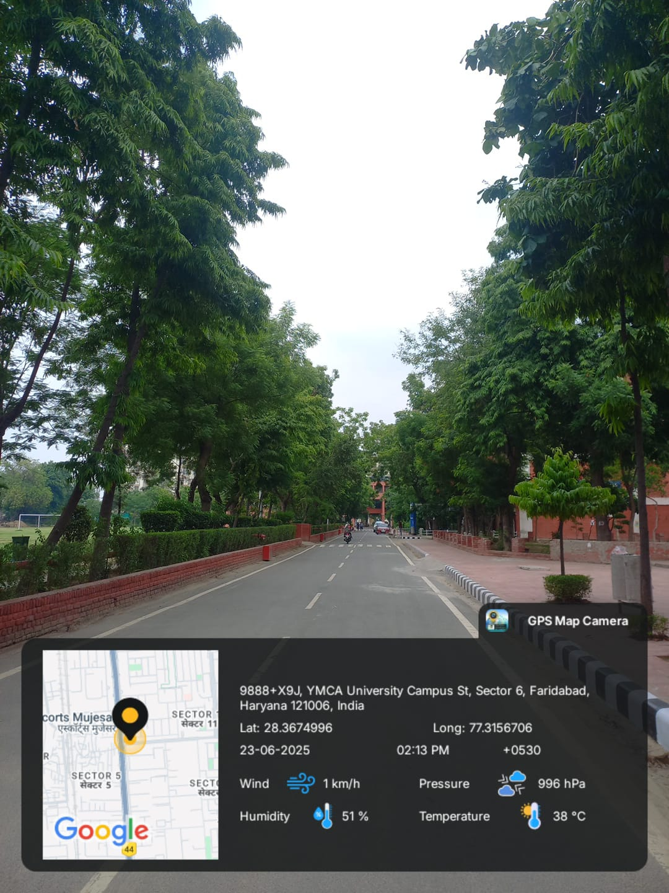

**PICTURE SHOWING LOCATION OF STIDIED AREA IN THE CAMPUS**

The university campus sprawls over **20 acres** and exhibits a planned layout with significant green cover, featuring numerous planted tree species and landscape elements. The institution lies in the **National Capital Region (NCR)**, approximately 30 km south of New Delhi, making it both urban and ecologically significant for studies concerning urban vegetation and anthropogenic ecological modifications.

**2. Climate Characteristics**

The climate of Faridabad, and hence the university campus, falls under the **tropical steppe, semi-arid (BSh)** category as per the **Köppen climate classification**. It is influenced by its inland position in northwestern India and exhibits significant **seasonal variability**.

**a. Temperature Profile:**

* **Summer (March to June)**: The region experiences high diurnal and seasonal temperatures. The maximum daily temperatures can rise above **45°C**, especially during May and June. The **mean monthly temperature** during peak summer ranges between **30–35°C**.
* **Winter (December to February)**: Winters are relatively mild and dry, with minimum temperatures occasionally dipping below **5°C**, especially in January. Fog and low visibility are common in early mornings.
* **Annual Mean Temperature**: Approximately **25°C**

**b. Rainfall:**

* The area receives most of its precipitation from the **Southwest Monsoon**, typically active from late June through September.
* **Average Annual Rainfall**: Approximately **600–800 mm**
* Rainfall is irregular and can be torrential, with inter-annual variability influenced by regional monsoon dynamics and El Niño–Southern Oscillation (ENSO) events.

**c. Humidity and Wind:**

* Humidity remains high during the monsoon season (up to 90%) and drops significantly in winter.
* The region experiences **dry northwesterly winds** in summer and **easterly moist winds** during the monsoon.

**3. Soil Profile and Edaphic Conditions**

The soil in and around the J. C. Bose University campus is part of the **Indo-Gangetic Alluvial Plain**, specifically falling under the **Newer Alluvium** category, shaped by the depositional activity of the Yamuna and its tributaries.

**a. Soil Type:**

* **Textural Class**: The predominant soil type is **loamy to sandy-loam**, with moderate silt and low clay content.
* **Color and Texture**: Typically light brown to pale yellowish-grey, moderately coarse in texture, with good permeability and moderate water-holding capacity.
* **Soil Reaction (pH)**: Generally **neutral to slightly alkaline** (pH 7.2–8.1), conducive for a wide range of angiospermic plant growth.
* **Porosity and Drainage**: The soil exhibits **good drainage**, but due to its relatively loose texture, it is susceptible to erosion if vegetation cover is insufficient.

**b. Organic Matter and Fertility:**

* **Organic Carbon Content**: Low to moderate; this is attributed to limited natural forest litter and high anthropogenic disturbance.
* **Macronutrients**: Nitrogen is relatively deficient; however, phosphorus and potassium levels are within acceptable limits for ornamental and native vegetation.
* **Edaphic Limitations**: The soil may require amendment in terms of organic compost or vermicompost for horticultural or afforestation programs.

**c. Anthropogenic Influence:**

* Urbanization and landscaping have altered the native soil profile in certain areas of the campus.
* Use of concrete pavements, artificial irrigation, and synthetic fertilizers have locally changed the **microbial profile and soil aeration dynamics**.

**4. Ecological Relevance**

The **semi-arid, alluvial soil environment** of the university provides a unique opportunity to study **urban biodiversity** under stress-prone climatic conditions. The diversity of **angiospermic species** present reflects **adaptive strategies** to seasonal drought, nutrient limitations, and high solar exposure. Furthermore, the university has undertaken tree plantation programs that contribute to **carbon sequestration**, **dust pollution reduction**, and **urban heat island mitigation**.

Species such as *Ficus religiosa*, *Mangifera indica*, *Cassia fistula*, and *Tectona grandis* are thriving under these edaphic and climatic conditions, demonstrating the resilience of selected native and exotic species under **controlled landscape management**.

**Methodology**

The present botanical survey was conducted within the premises of **J. C. Bose University of Science and Technology, YMCA**, located in Faridabad, Haryana. The primary objective of the survey was to document the plant diversity within the university campus and to assess the ecological and ethnobotanical significance of the recorded species. The methodology adopted for the survey integrates modern digital tools, field-based observations, and local ecological knowledge.

**1. Survey Design and Scope**

A **qualitative and observational survey** method was employed. The study area was systematically explored over multiple visits during the early morning and late afternoon hours to ensure proper visibility and minimize plant wilting under midday heat. Each accessible region within the campus, including academic blocks, garden areas, roadside plantations, and recreational zones, was covered to record the full range of vascular plant species, primarily angiosperms.

**2. Plant Identification Procedure**

The plant species were identified based on morphological characters such as leaf arrangement, flower structure, stem type, bark texture, and overall growth habit. A **two-step identification protocol** was followed:

**a. Use of Google Lens (AI-Based Image Recognition Tool):**

* **Google Lens**, a mobile-based visual recognition application, was used extensively as a **primary plant identification tool**.
* Clear and well-lit photographs of individual plants (leaves, flowers, bark, or fruits) were taken and uploaded to the Google Lens interface for real-time identification.
* Preliminary identification was noted and further verified manually using secondary sources.

**b. Consultation with Local Experts:**

* In cases where Google Lens failed to yield accurate or satisfactory results, **on-site verification was conducted** by consulting the university’s **gardener, landscape supervisor, or horticultural maintenance staff**.
* This step was crucial in confirming the identification of species with **ambiguous or overlapping morphological features**.

**3. Data Documentation and Cataloguing**

Once identified, the plant species were catalogued in a tabular format including the following parameters:

* **Botanical Name**
* **Common Name**
* **Family**
* **Division (Monocot/Dicot)**
* **Habit (Tree, Shrub, Herb, Climber, Grass)**
* **Documented Uses** (Ornamental, Medicinal, Timber, Edible, etc.)

Data were initially recorded in field notebooks and subsequently digitized for analysis and report preparation.

**4. Supplementary Research and Literature Review**

After the preliminary identification, **internet-based research** was undertaken to gather additional details regarding the:

* **Ethnobotanical uses**
* **Ecological roles**
* **Habitat preferences**
* **Economic importance**
* **Taxonomic classification**

Information was cross-verified using reliable sources such as:

* **The Plant List (**[**http://www.theplantlist.org**](http://www.theplantlist.org/)**)**
* **India Biodiversity Portal**
* **Forest Research Institute (FRI) publications**
* **Google Scholar and peer-reviewed articles**

Scientific names were verified for taxonomic correctness and updated nomenclature was adopted wherever necessary.

**5. Ethical and Environmental Considerations**

* No plant was uprooted, damaged, or harmed during the survey.
* Only **non-invasive observational methods** were employed.
* Photographs and digital tools were used in place of physical collection to maintain ecological integrity.

**Site A – Nursery: Observational Report**

The nursery at J.C. Bose University of Science and Technology, YMCA (Site A), functions as a controlled microhabitat showcasing a wide range of horticultural and medicinal plant species. It serves not only as a visual and ecological asset but also as a vital educational resource for botanical surveys, ecological studies, and plant taxonomy practicals. The nursery is organized into patches based on the growth habit and utility of the plants—herbs, shrubs, climbers, and trees.

This report documents the qualitative observations and ecological significance of the plant diversity recorded at Site A, which comprises ornamental, medicinal, edible, and air-purifying plant species. A total of **63 angiospermic and gymnospermic species** were observed and studied.

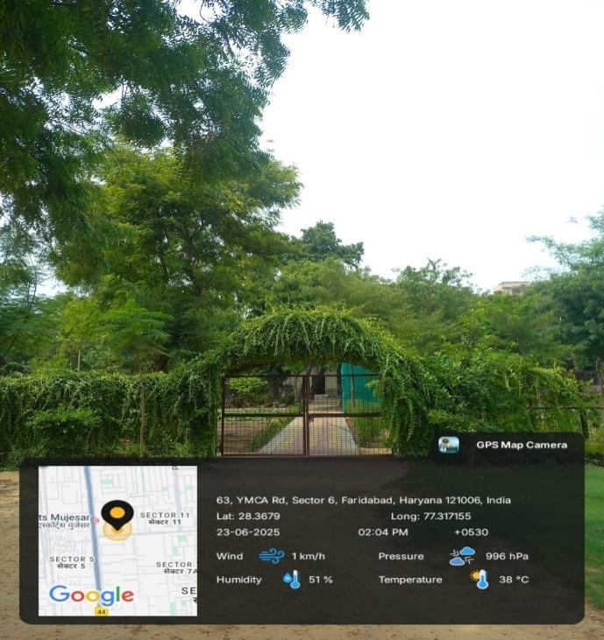

**Fig. 1:** Site A- Nursery

**Habitat and Floristic Composition**

The nursery supports a rich array of flora predominantly belonging to the **angiosperm division**, with both **monocotyledonous and dicotyledonous** representatives. The growth habits of these plants range from **herbs and shrubs to climbers and trees**, with additional representation from gymnosperms such as *Cycas revoluta* and *Araucaria araucana*.

**Dominant Families Identified:**

* **Fabaceae**: e.g., *Dalbergia sissoo*, *Delonix regia*, *Saracaasoca*
* **Lamiaceae**: e.g., *Ocimum tenuiflorum*, *Melissa officinalis*
* **Araceae**: e.g., *Epipremnumaureum*, *Chlorophytum comosum*
* **Malvaceae**: e.g., *Hibiscus rosa-sinensis*, *Abelmoschus esculentus*
* **Cucurbitaceae**: e.g., *Luffa acutangula*, *Cucumis callosus*

The diversity also reflects a thoughtful selection of **ornamental**, **medicinal**, **fruit-yielding**, and **air-purifying** species. Their placement in well-structured beds and climber-support frames demonstrates effective spatial planning for both accessibility and sunlight exposure.

**Notable Observations**

**1. Ornamental and Air-Purifying Species**

Several species are cultivated for their aesthetic value and ecological contributions to air quality:

* *Dracaena trifasciata* (Snake Plant), *Zamioculcaszamiifolia* (ZZ Plant), *Chlorophytum comosum* (Spider Plant), and *Epipremnumaureum* (Money Plant) were noted for their **high indoor air-purification efficiency**.
* *Bougainvillea glabra* and *Allamanda cathartica* provided vibrant floral display and served as **natural fencing and erosion control** agents.

**2. Medicinal Plants**

A significant portion of the nursery consists of plants with documented medicinal uses in traditional systems such as Ayurveda and Unani:

* *Azadirachta indica* (Neem) – antibacterial, anti-inflammatory
* *Ocimum tenuiflorum* (Tulsi) – antimicrobial, adaptogenic
* *Phyllanthus emblica* (Amla) – rich in Vitamin C, immunomodulatory
* *Bryophyllumpinnatum* – used in wound healing and renal ailments

These plants are strategically positioned in areas of high visibility to promote awareness among students and staff about **native ethnomedicinal resources**.

**3. Edible and Nutraceutical Plants**

Species such as *Musa acuminata* (Banana), *Psidium guajava* (Guava), *Carica papaya* (Papaya), and *Mentha spicata* (Spearmint) demonstrate the utility of the nursery beyond landscaping—serving also as a **functional edible garden**.

* Leafy herbs like *Curry Leaf* and *Ajwain* also contribute to the aromatic and culinary diversity of the site.

**Ecological and Educational Importance**

The nursery is an excellent model of **biodiversity conservation in semi-urban academic spaces**. The selection of plants reflects both native and exotic species, ensuring genetic diversity and ecological balance.

Furthermore, the nursery provides:

* **Habitat for pollinators** like bees and butterflies due to the presence of flowering plants like *Helianthus annuus* (Sunflower) and *Tagetes spp.* (Marigold).
* **Live demonstrations for students** of plant morphology, medicinal botany, and environmental science.

The plants are labeled and maintained with assistance from skilled gardeners, ensuring that species are easily identifiable for academic and survey purposes.

Site A – the Nursery – represents a meticulously curated botanical zone that integrates ecological sustainability with aesthetic and educational functionality. The high floristic diversity observed—comprising species of horticultural, medicinal, and ecological relevance—demonstrates the university’s commitment to green infrastructure and environmental awareness.

It not only serves as a **green lung** within the campus but also as a **living laboratory** for botany students, fostering hands-on learning, conservation ethics, and a deeper understanding of plant taxonomy and physiology.

Table 1: Site A-Nursery

|  |  |  |  |  |  |  |
| --- | --- | --- | --- | --- | --- | --- |
| Sr. No. | Botanical Name | Common Name | Family | Division | Habit | Uses |
| 1 | Thunbergia alata | Curtain Creeper | Asteraceae | Angiosperms (Dicots) | Shrub | Ornamental purpose, privacy screen, air purification |
| 2 | Hibiscus rosa-sinensis | China Rose | Malvaceae | Angiosperms (Dicots) | Shrub | Tea, natural dye, ornamental, hair care, traditional medicine |
| 3 | Azadirachta indica | Neem | Meliaceae | Angiosperms (Dicots) | Tree | Antibacterial, anti-inflammatory, skincare, insect repellent |
| 4 | Luffa acutangular | Ridge Gourd | Cucurbitacee | Angiosperms (Dicots) | Climber | Edible vegetable, used as sponge, fiber for hats |
| 5 | Neltumajuliflora | Mesquite | Fabaceae | Angiosperms(Dicots) | Shrub | Fuelwood, livestock fodder, human food, timber |
| 6 | Epipremnumaureum | Golden Pothos | Araceae | Angiosperms (Monocot) | Climber | Air purifier, antidiabetic, anti-inflammatory, wound healing |
| 7 | Citrus × aurantiifolia | Lemon | Rutaceae | Angiosperms (Dicots) | Tree | Vitamin C, antioxidant, reduces inflammation, collagen production |
| 8 | Manilkara zapota | Chikoo | Sapotaceae | Angiosperms(Dicots) | Tree | Sugars, vitamins A&C, fiber, antioxidant |
| 9 | Cordyline fruticose | Palm Lily | Asparagacee | Angiosperms (Monocot) | Shrub | Leaves for sssssfood wraps, decoration, fevers, wounds, mild alcoholic beverages |
| 10 | Graptophyllumpictum | Caricature Plant | Acanthaceae | Angiosperms (Dicots) | Shrub | Skin conditions, inflammation, coughs, nephroprotective |
| 11 | Syngonium podophyllum | Arrowhead Plant | Araceae | Angiosperms(Monocots) | Climber | Indoor ornamental, air purification, Feng Shui, Vastu |
| 12 | Portulacaria afra | Elephant Bush | Didiereaceae | Angiosperms(Dicots) | Shrub | CO₂ absorption, edible leaves, elephant fodder |
| 13 | Asparagus meyeri | Foxtail Fern | Asparagaceae | Angiosperms(Monocots) | Shrub | Ornamental, air purification, landscaping |
| 14 | Crinum asiaticum | Poison Bulb / Spider Lily | Amaryllidaceae | Angiosperms(Monocots) | Herb | Ornamental, swelling, wounds, rheumatism |
| 15 | Euphorbia tithymaloides | Devil’s Backbone | Euphorbiaceae | Angiosperms  (Dicots) | Shrub | Skin diseases, ornamental |
| 16 | Scadoxusmultiflorus | Blood Lily | Amaryllidaceae | Angiosperms  (Monocots) | Herb | Ornamental, traditional medicine |
| 17 | Syngonium podophyllum | Arrowhead Plant | Araceae | Angiosperms  (Monocots) | Climber | Indoor ornamental, air purifying |
| 18 | Epipremnumaureum | Money Plant | Araceae | Angiosperms  (Monocots) | Climber | Indoor plant, air purification |
| 19 | Crinum latifolium | Crinum Lily | Amaryllidaceae | Angiosperms  (Monocots) | Herb | Traditional medicine (anti-uterine disorders) |
| 20 | Zamioculcaszamiifolia | ZZ Plant | Araceae | Angiosperms  (Monocots) | Herb | Ornamental, drought-tolerant indoor plant |
| 21 | Clerodendrum inerme | Glory Bower | Lamiaceae | Angiosperms  (Dicots) | Shrub | Medicinal, ornamental hedge plant |
| 22 | Bougainvillea glabra | Bougainvillea | Nyctaginaceae | Angiosperms  (Dicots) | Climber/Shrub | Ornamental, fencing, landscaping |
| 23 | Dracaena trifasciata | Snake Plant | Asparagaceae | Angiosperms  (Monocots) | Herb | Air purifier, ornamental indoor plant |
| 24 | Saracaasoca | Ashoka Tree | Fabaceae | Angiosperms  (Dicots) | Tree | Medicinal (gynecological), sacred |
| 25 | Musa acuminata | Banana | Musaceae | Angiosperms  (Monocots) | Herb | Edible fruit, fiber, medicinal use |
| 26 | Psidium guajava | Guava | Myrtaceae | Angiosperms  (Dicots) | Tree | Edible fruit, rich in vitamin C, medicinal |
| 27 | Manilkara zapota | Sapodilla (Chikoo) | Sapotaceae | Angiosperms  (Monocots) | Tree | Edible fruit, chewing gum base |
| 28 | Citrus limon | Lemon | Rutaceae | Angiosperms  (Monocots) | Shrub/Tree | Edible fruit, juice, vitamin C, medicinal |
| 29 | Solanum lycopersicum | Tomato | Solanaceae | Angiosperms  (Dicots) | Herb | Edible fruit (vegetable), rich in antioxidants |
| 30 | Cycas revoluta | Sago Palm | Cycadaceae | Gymnosperms  (Monocots) | Shrub/Cycad | Ornamental, toxic if ingested |
| 31 | Chlorophytum comosum | Spider Plant | Asparagaceae | Angiosperms  (Monocots) | Herb | Ornamental, air purifying indoor plant |
| 32 | Helianthus annuus | Sunflower | Asteraceae | Angiosperms  (Dicots) | Herb | Edible oil, ornamental, seeds |
| 33 | Manilkara hexandra | Khirni | Sapotaceae | Angiosperms  (Monocots) | Tree | Edible fruits, timber, medicinal |
| 34 | Carica papaya | Papaya | Caricaceae | Angiosperms  (Dicots) | Small tree | Fruit, latex used medicinally |
| 35 | Bryophyllumpinnatum | Air plant / Pattharchat | Crassulaceae | Angiosperms  (Dicots) | Herb | Medicinal (wound healing, kidney stones) |
| 36 | Abelmoschus esculentus | Lady's Finger / Bhindi | Malvaceae | Angiosperms  (Dicots) | Herb | Edible vegetable, medicinal |
| 37 | Allamanda cathartica | Yellow Bell | Apocynaceae | Angiosperms  (Dicots) | Shrub | Ornamental, medicinal |
| 38 | Colocasia esculenta | Taro | Araceae | Angiosperms  (Monocots) | Herb | Edible corms, leaves used in cuisine |
| 39 | Trachyspermumammi | Ajwain | Apiaceae | Angiosperms  (Dicots) | Herb | Culinary spice, digestive aid |
| 40 | Murrayakoenigii | Curry Leaf | Rutaceae | Angiosperms  (Dicots) | Shrub | Culinary spice, medicinal |
| 41 | Oroxylum indicum | Indian trumpet tree | Bignoniaceae | Angiosperms  (Dicots) | Tree | Medicinal (bark, root), ornamental |
| 42 | Asparagus racemosus | Shatavari | Asparagaceae | Angiosperms  (Monocots) | Climber | Medicinal (reproductive health) |
| 43 | Melissa officinalis | Lemon balm | Lamiaceae | Angiosperms  (Dicots) | Herb | Calming, medicinal tea |
| 44 | Senna siamea | Kassod tree | Fabaceae | Angiosperms  (Dicots) | Tree | Medicinal, ornamental, timber |
| 45 | Ocimum tenuiflorum | Holy Basil / Tulsi | Lamiaceae | Angiosperms  (Dicots) | Herb | Medicinal, religious importance |
| 46 | Pachystachys lutea | Lollipop plant | Acanthaceae | Angiosperms  (Dicots) | Shrub | Ornamental |
| 47 | Zehneria scabra | Wild cucumber | Cucurbitaceae | Angiosperms  (Dicots) | Climber | Medicinal, edible fruits |
| 48 | Chlorophytum borivilianum | Safed musli | Asparagaceae | Angiosperms  (Monocots) | Herb | Aphrodisiac, medicinal |
| 49 | Delonix regia | Gulmohar | Fabaceae | Angiosperms  (Dicots) | Tree | Ornamental, shade |
| 50 | Livistona chinensis | Chinese fan palm | Arecaceae | Angiosperms  (Monocots) | Tree | Ornamental |
| 51 | Boehmeria nivea | Ramie | Urticaceae | Angiosperms  (Dicots) | Herb | Fibre plant |
| 52 | Michelia alba | White champaca | Magnoliaceae | Angiosperms  (Dicots) | Tree | Ornamental, fragrant flowers |
| 53 | Chamaedoreaseifrizii | Bamboo palm | Arecaceae | Angiosperms  (Monocots) | Shrub | Indoor ornamental |
| 54 | Araucaria araucana | Monkey puzzle tree | Araucariaceae | Gymnosperms  (Monocots) | Tree | Ornamental, timber |
| 55 | Morus alba | White mulberry | Moraceae | Angiosperms  (Dicots) | Tree | Sericulture, fruits edible |
| 56 | Dalbergia sissoo | Indian rosewood / Shisham | Fabaceae | Angiosperms  (Dicots) | Tree | Timber, medicinal |
| 57 | Phyllanthus emblica | Amla / Indian gooseberry | Phyllanthaceae | Angiosperms  (Dicots) | Tree | Vitamin C, medicinal |
| 58 | Tecomella undulata | Desert teak | Bignoniaceae | Angiosperms  (Dicots) | Tree | Timber, drought-resistant |
| 59 | Syzygiumcumini | Jamun | Myrtaceae | Angiosperms  (Dicots) | Tree | Fruit, diabetes treatment |
| 60 | Tecoma stans | Yellow elder | Bignoniaceae | Angiosperms  (Dicots) | Shrub | Ornamental, medicinal |
| 61 | Cucumis callosus | Wild melon | Cucurbitaceae | Angiosperms  (Dicots) | Climber | Traditional medicine |
| 62 | Mentha spicata L. | Spearmint | Lamiaceae | Angiosperms  (Dicots) | Herb | Flavoring, digestive, aromatic |
| 63 | Lawsonia inermis | Henna | Lythraceae | Angiosperms(Dicots) | Shrub | Hair dye, cooling agent |

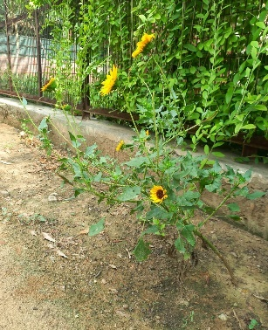

(a) *Hibiscus sp.* (b) *Graptophyllum pictum* (c) *Helianthus annuus* (d) *Citrus Lemon*

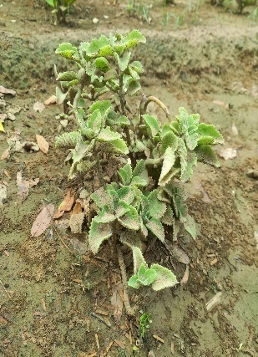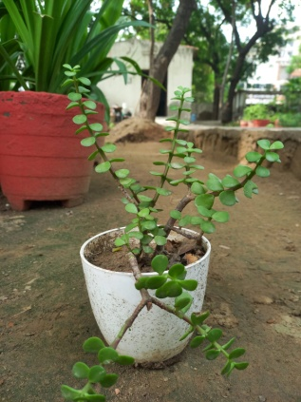

(e) *Solanum melogena* (f) *Carica papaya* (g) *Trachyspermum ammi* (h) *Portulacaria afra*

**Site B – Greenhouse: Observational Report**

The **greenhouse at J. C. Bose University of Science and Technology, YMCA (Site B)** is a controlled microclimatic enclosure dedicated to the conservation, cultivation, and study of diverse plant taxa. Designed to simulate specific humidity and light conditions favorable for sensitive and exotic flora, the greenhouse functions as both an **educational laboratory** and a **conservation unit**. This observational survey documented a wide array of species including **tropical ornamentals, aromatic herbs, rare medicinal plants, succulents, palms, and climbers**.

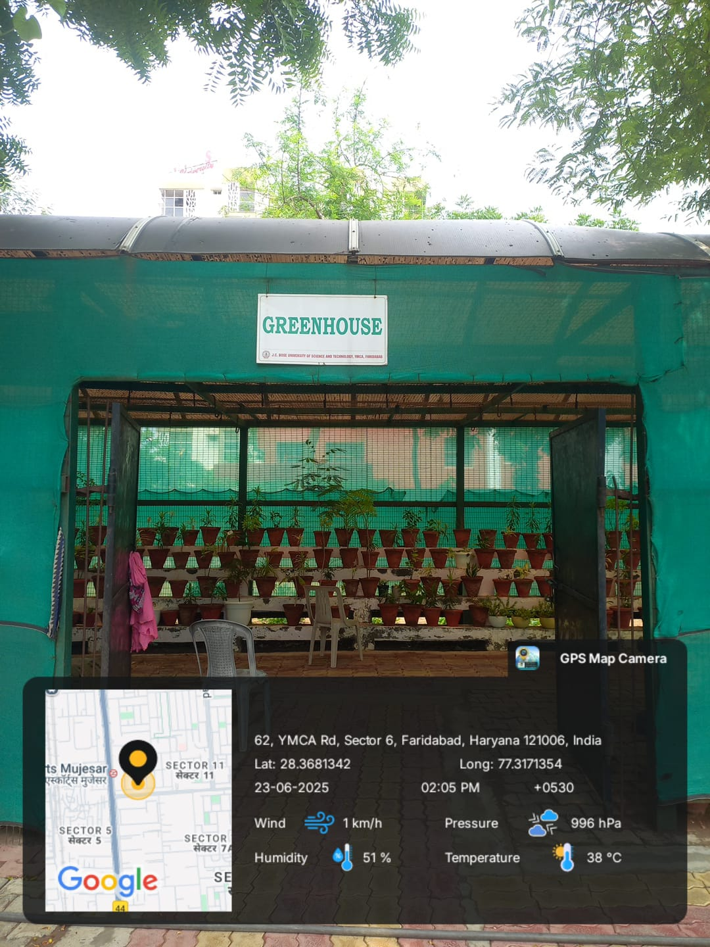The total collection surveyed comprises over **40 species**, many of which are native to tropical regions and exhibit unique adaptations suitable for controlled environments.

**Fig. 2:** Site B – Greenhouse

**Habitat and Floristic Composition**

Unlike open-field plantations, the greenhouse supports species that **require moderate to high humidity**, **consistent ambient temperature**, and **partial to filtered sunlight**. The species cultivated here span across a range of plant types including:

* **Herbs** (*Lavandula angustifolia*, *Bacopa monnieri*, *Papaver somniferum*)
* **Shrubs** (*Codiaeum variegatum*, *Crossandrainfundibuliformis*, *Calotropis gigantea*)
* **Trees and woody perennials** (*Ficus retusa*, *Ficus elastica*, *Araucaria heterophylla*)
* **Palms and cycads** (*Pichodia grandis*, *Livistona chinensis*, *Cycas revoluta*, *Hyophorbelagenicaulis*)
* **Climbers** (*Piper nigrum*, *Passiflora incarnata*, *Clematis heynei*)
* **Ferns and succulents** (*Nephrolepisexaltata*, various succulent species)

**Notable Observations**

**1. Ornamental and Tropical Foliage Plants**

The greenhouse is home to numerous plants with high ornamental value:

* *Codiaeum variegatum* (Trishul Croton): Noted for its vibrant, variegated foliage, thriving in filtered light.
* *Cordyline terminalis* (Dracaena Mahatma): Grown for colorful leaves; requires high humidity.
* *Araucaria heterophylla* (Norfolk Island Pine): Popular during the winter season as a decorative “Christmas tree.”
* *Succulents* (5 varieties): Displayed for their drought tolerance and aesthetic appeal in interior landscaping.

**2. Medicinal and Aromatic Species**

A range of plants traditionally used in herbal medicine and aromatherapy are cultivated:

* *Lavandula angustifolia* (English Lavender): Known for its calming fragrance and essential oil production.
* *Bacopa monnieri* (Brahmi): Used for memory enhancement and neurological disorders in Ayurveda.
* *Papaver somniferum* (Opium Poppy): Noted for its historical pharmaceutical relevance (alkaloids).
* *Artemisia abrotanum* (Davana): Aromatic herb used in traditional medicine and perfumery.

**3. Climbers and Epiphytes**

Climbing plants are strategically supported along vertical frames:

* *Piper nigrum* (Black Pepper): A tropical climber valued for its spice and medicinal properties.
* *Passiflora incarnata* (Passionflower): Cultivated for ornamental flowers and calming medicinal uses.
* *Clematis heynei* (Ranjai): A native climber with ecological and aesthetic significance.

**4. Palms and Cycads**

Exotic palms and cycads provide a vertical dimension and tropical appeal:

* *Pichodia grandis* (Ruffled Fan Palm), *Livistona rotundifolia*, and *Hyophorbelagenicaulis* (Bottle Palm): All well-suited to greenhouse conditions.
* *Cycas revoluta* (Sago Palm): A gymnosperm with ancient lineage, placed centrally for visual impact.

**5. Native Medicinal and Fragrant Species**

The greenhouse also includes **aromatic and ethnobotanically important plants** like:

* *Trachyspermumammi* (Ajwain), *Elettaria cardamomum* (Elaichi), *Ocimum tenuiflorum* (Tulsi), *Jasminum sambac* (Mogra), and *Tecoma sp.* (Trumpet Bush), which are regularly monitored for growth and flowering under controlled humidity.

**Educational and Ecological Significance**

The greenhouse serves as a **living repository** of phytodiversity, particularly for species not suitable for open cultivation due to climatic limitations. It provides:

* A **microclimatic training space** for botany students to study plant growth under artificial conditions.
* A collection of **economically and medicinally important species** that support pharmacognosy and horticulture education.
* **Year-round flowering plants** that support ongoing observational studies on phenology, pollination, and plant physiology.

The diversity of plants also supports **pollinator species** and encourages awareness on **sustainable indoor gardening practices**.

Site B – the Greenhouse – represents an integrative space that harmonizes **aesthetic beauty, scientific utility, and ecological awareness**. The curated plant collection displays an impressive range of morphologies, adaptations, and uses—from succulents and spices to palms and poppies.

This carefully maintained environment allows for:

* **Conservation of delicate and exotic species**
* **Practical training in plant propagation and care**
* **A model for sustainable indoor plant cultivation**

Its diversity and meticulous arrangement underscore its role as an essential component of the university's botanical infrastructure.

|  |  |  |  |  |  |  |
| --- | --- | --- | --- | --- | --- | --- |
| **Sr. No.** | **Botanical Name** | **Common Name** | **Family** | **Division** | **Habit** | **Uses** |
|  | *Codiaeum Variegatum* | Trishul Croton | Euphorbiaceae | Angiosperms  (dicot) | Shrub | Popular house plant for its vibrant colourful foliage ,pain relief, Wound healing, treating digestive issues like diarrhea and dysentery used for treating |
|  | *Ficus retusa* | Fig tree | Moraceae | Moraceae | Tree | Decorative house plant, to treat liver disease,wounds,ulcers |
|  | *Ficus benjamina* | Starlight/weeping fig | Moraceae | Angiosperms  (dicot) | Tree | Treatment of rheumatic headaches, treat skin and respiratory disorders. |
|  | *Cordyline Terminalis M* | Dracaena Mahatma | Asparagaceae | Angiosperms  (monocot) | Shrub | Ideal for indoor decoration, enhancing aesthetics.  Used in air purification n, improving indoor air quality. |
|  | *Pichodia grandis* | Pichodia Palm/ Ruffled fan palm | Arecaceae | Angiosperms  (monocot) | Tree | Used for landscaping, ideal for indoor decoration, enhancing air quality. |
|  | *Livistona rotundifolia* | Footstool Palm | Arecaceae | Angiosperms  (monocot) | Tree | Preventing soil erosion, wrapping food. |
|  | *Cinnamom verum* | True Cinnamon | Lauraceae | Angiosperms  (dicot) | Tree | Manage blood sugars, protect against heart disease, and reduce inflammation. |
|  | *Ficus elastica* | Rubber fig | Moraceae | Angiosperms  (dicot) | Tree | * Beneficial for constipation and  used as shade tree in parks and public spaces. |
|  | *Lavandula angustifolia* | Silver mist/English Lavender/Silver frost | Lamiaceae | Angiosperms  (dicot) | Shrub | * Herbal medicine and herbal tea, Lotions, soap, eye pillows. |
|  | *Gerbera jamesonii* | Gerbera daisiy/African daisy | Asteraceae | Angiosperms  (dicot) | Herb | Treat various ailments, including stomach problems, headaches, and respiratory issues. |
|  | *Cyperus Alternifolius* | umbrella papyrus/umbrella sedge or umbrella palm | Cyperaceae | Angiosperms  (monocot) | Herb | Natural air purifier, used as ornamental purpose. |
|  | *Platycladusorientalis* | Oriental/chinese Thuja | Cuperaceae | Gymnosperm | Shrub | Skin diseases Employed on warts, eczema, and fungus infections as it is anti-inflammatory and antiseptic. |
|  | *Araucaria heterophylla* | Christmas Tree | Araucariaceae | Gymnosperm | Tree | 1. Making pine needle tea and 2. Supporting local wildlife, using branches to stake plants. |
|  | *Papaver somniferum* | Opium poppy | Papaveraceae | Angiosperms  (dicot) | Herb | The seeds are used in bakery products, seasoning, oil, and birdseed. |
|  | *Cycas revoluta* | sago palm, king sago, sago cycad | Cycadaceae | Gymnosperm | Shrub | Sago Palm fronds are regularly used in the florist industry.  used as a traditional medicine to cure blood vomiting, skin diseases, hypertension, |
|  | *Cestrum nocturnum* | the lady of the night, night-blooming jessamine, night-scent e | Solanaceae | Angiosperms  (dicot) | Shrub | Used as a hedge plant and cultivated as a medicinal plant. The medicinal properties of night blooming jasmine include antioxidants, analgesic. |
|  | *Nephrolepisexaltata* | swordfern or Boston fern | Nephrolepidaceae | Pteridophyte | Herb | Providing nesting and cover for birds, deer, and small mammals.   * Being used on berry-drying racks and to separate food in storage. |
|  | *Trachyspermumammi* | Ajowan caraway, thymol seeds, bishop's weed, or carom | Apiaceae | Angiosperms  (dicot) | Herb | Digestion and to increase appetite,  Treating respiratory disorders,  Analgesic properties. |
|  | *Jasminum multiflorum* | Star jasmine/chameli | Oleaceae | Angiosperms  (dicot) | Shrub | The leaf is restorative and tonic. useful for the aged,  The seed is cardio tonic and hemostatic. |
|  | *Calotropis gigantea* | White Aak Plant/Giant Milkweed, Crown Flower, Giant Calot | Apocynaceae | Angiosperms  (dicot) | Shrub | Used to induce vomiting as well as purgation, relief of bloating, gas, and stomach distension caused by incorrect food digestion. |
|  | *Livistona chinensis* | Chinese fan palm or fountain palm | Arecaceae | Angiosperms  (monocot) | Tree | Landscaping, thatching and wrapping, making hats fans, raincoats. |
|  | *Hyophorbelagenicaulis* | Rexona Palm/the bottle palm or palmistegargoulette | Arecaceae | Angiosperms  (monocot) | Tree | Cosmetic and aesthetic purposes,  Bath crates,  Fuel biomass,  Oil making,  Used as an ornamental plant. |
|  | *Hibiscus moscheutos* | Rose mallow | Malvaceae | Angiosperms  (dicot) | Shrub | Ornamental gardening, supporting pollinators and treat coughs and digestive issues. |
|  | *Campsis radicans.* | Trumpet bush | Bigoniaceae | Angiosperms  (dicot) | Shrub | Used in **fences, trellises, walls, arbors, andprivacy barriers**. Aside from the color and texture, the Trumpet Vine adds to the landscape. It also attracts butterflies, bees, and hummingbirds which could give the space a more natural vibe. This makes it a great addition to pollinator gardens. |
|  | *Mimosa Pudica* | Touch me not or chuimui | Fabaceae | Angiosperms  (dicot) | Herb | Used to treat various ailments, including skin conditions and digestive issues.  Used as anti-asthmatic, pain killing and antidepressant remedy. |
|  | *Crossandrainfundibuliformis* | Firecracker flower | Acanthaceae | Angiosperms  (dicot) | Shrub | Used for decoration, particularly in temples and hair adornments.  Used in landscaping also used for treat various ailments like fever, headache, and pain, as well as wound healing. |
|  | *Plumbago auriculata* | Cape Leadwort | Plumbaginaceae | Angiosperms  (dicot) | Shrub | Used to treat skin diseases, digestive disorders, and rheumatic conditions, also used for ornamental plants. |
|  | *Passiflora incarnata* | Passion Flower, Krishna Kamal | Passifloraceae | Angiosperms  (dicot) | Climber | Used to manage anxiety, insomnia, and nervous disorders.  It may help with muscle spasms, pain relief, and even certain respiratory issues. |
|  | *Hibiscus sp. (Red)* | Gudhal Flower | Malvaceae | Angiosperms  (dicot) | Shrub | Used for culinary, medicinal, and cosmetic applications.  It is used for potentially lower blood pressure and cholesterol, antioxidant, antimicrobial, and promote hair growth, prevent hair fall, and add shine. |
|  | *Lantana camara* | Lavender | Lamiaceae | Angiosperms  (dicot) | Shrub | Used to treat skin itches, wounds, chicken pox, ulcers, mosquito control. |
|  | *Jasminum sambac,* | Mogra, Arabian Jasmine | Oleaceae | Angiosperms  (dicot) | Shrub | Used in perfumes,religious ceremonies, and for making garlands. |
|  | *Clematis heynei* | Ranjai Plant | Ranunculaceae | Angiosperms  (dicot) | Climber | Used in landscaping and traditional medicine. |
|  | *Bacopa monnieri* | Brahmi Big leaf | Plantaginaceae | Angiosperms  (dicot) | Herb | Contains powerful antioxidants, reduce inflammation,boost brain function. |
|  | *Asparagus Meyeri* | Fox tail Asparagus | Asparagaceae | Angiosperms  (monocot) | Shrub | Ornamental plant ,indoor and outdoor decoration. |
|  | *Artemisia Abrotanum* | Davana | Asteraceae | Angiosperms  (dicot) | Shrub | Used in medicinal, culinary, and insect repellent applications. |
|  | *Syzium aromaticum* | Clove | Myrtaceae | Angiosperms  (dicot) | Tree | Used as spice in cooking adding flavor to dishes, used to relieve toothaches,improve oral hygiene. |
|  | *Elettaria cardamomum* | Elaichi | Zingiberaceae | Angiosperms  (monocot) | Shrub | Used to flavor dishes, freshen breath, and digestive aid. |
|  | *Piper nigrum* | Black pepper | Piperaceae | Angiosperms  (dicot) | Climber | Used as a spice to add flavor and heat to food,potentially boost metabolism, may help manage blood pressure. |

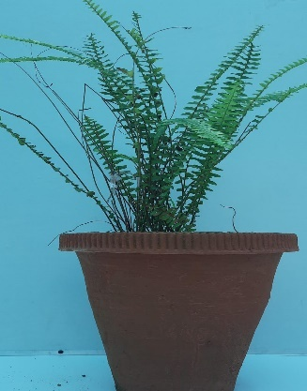

(a) *Araucaria* (b)*Bryophyylum* (c)*Varigated* (d)*Nephrolepis*

*heterophylla pinetum pittosporum exalata*

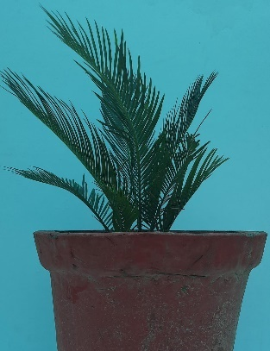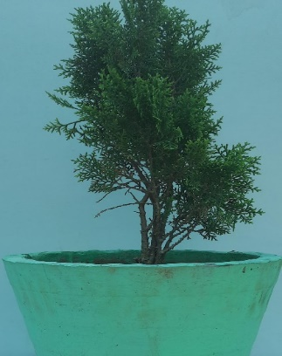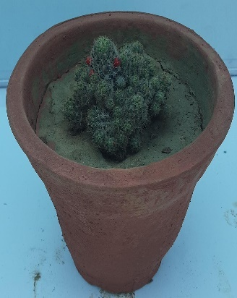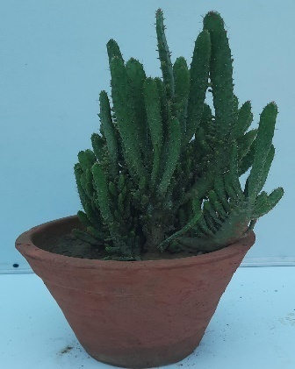

(e) *Cycas* (f)*Platycladus* (g)*Mammillaria* (h)*Euphorbia* sp.

*revoluta orientalis prolifera*

**Site C – V.C. Office Park: Observational Report**

The **Vice Chancellor's Office Park** at J.C. Bose University of Science and Technology, YMCA (Site C), is a well-maintained and biodiverse green space designed to offer both aesthetic appeal and ecological balance. Located around the administrative block, this site reflects a curated integration of **native and exotic ornamental, medicinal, and shade-providing plants**. It serves as a microhabitat that supports urban biodiversity and contributes to microclimate regulation within the campus's administrative core.

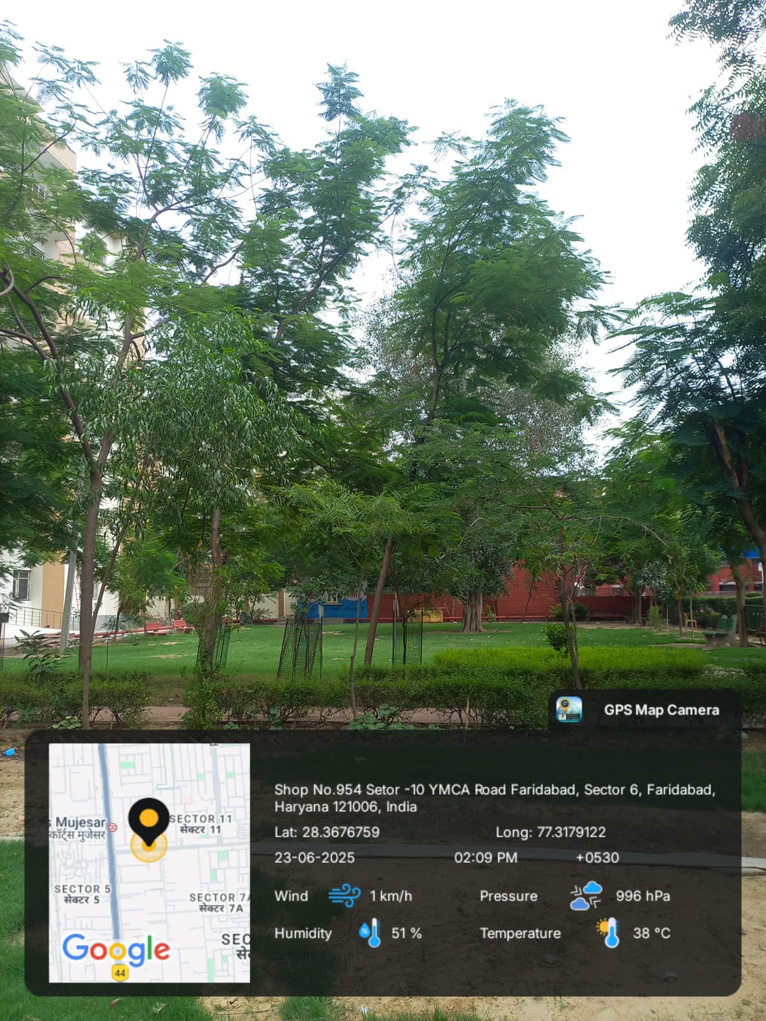This observation focuses on the plant diversity found in the V.C. Office Park, analyzing the **growth habit, botanical identity, utility**, and **ecological function** of each species recorded during the survey.

**Fig. 3:** Site C – V.C. Office Park

**Habitat and Floristic Composition**

Site C consists of an open, partially shaded area interspersed with pathways, lawns, and shrub beds. The flora observed here represents a **dominantly dicotyledonous angiosperm composition**, with the presence of large perennial trees, flowering shrubs, aromatic herbs, and shade-tolerant species. The selection appears optimized for **low-maintenance landscaping**, air purification, and cultural symbolism.

**Growth Habit Distribution:**

* **Trees**: *Ficus microcarpa*, *Dalbergia sissoo*, *Tamarindus indica*, *Saracaasoca*
* **Shrubs**: *Hibiscus rosa-sinensis*, *Alcea rosea*, *Nerium oleander*
* **Herbs**: *Tagetes minuta*, *Catharanthus roseus*, *Aganonerionpolymorphum*

**Notable Observations**

**1. Shade and Air-Purifying Trees**

Several large tree species are planted for their **shade-giving canopy** and **air purification properties**:

* *Ficus benghalensis* (Banyan) and *Ficus religiosa* (Peepal) are not only ecologically significant but also revered in Indian culture.
* *Syzygiumcumini* and *Ficus benjamina* function as effective **dust filters and oxygen providers** in urban landscapes.
* *Azadirachta indica* (Neem) and *Eucalyptus hybrida* (Safeda) are known for their antimicrobial effects and volatile organic compound (VOC) reduction capacity.

**2. Medicinal and Aromatic Plants**

The site contains species with diverse medicinal uses:

* *Catharanthus roseus*: Noted for alkaloids used in anti-cancer therapies.
* *Phyllanthus emblica* (Amla): A rich source of Vitamin C, used in immunity enhancement.
* *Moringa oleifera*: A nutraceutical plant with wide medicinal potential, especially for blood sugar regulation.
* *Terminalia arjuna*: Renowned for cardioprotective properties.

These species contribute to **in-situ ethnobotanical education** and potential pharmacognostic studies.

**3. Ornamental and Landscaping Plants**

The flowering shrubs and herbs enhance the aesthetic character of the space:

* *Hibiscus rosa-sinensis*, *Tecoma stans*, and *Cassia fistula* offer seasonal flowering and pollinator support.
* *Magnolia champaca* emits fragrant blooms that are also used in perfumery.
* *Tagetes minuta* (Marigold) provides natural pest-repellent and ornamental value.

The deliberate arrangement of flowering plants near pedestrian paths and entryways fosters a **visually appealing and biologically diverse environment**.

**4. Biodiversity and Ecosystem Role**

The V.C. Office Park also includes **pollinator-attracting and nitrogen-fixing species**, such as:

* *Albizia lebbeck* and *Leucaena leucocephala*, which enrich the soil.
* *Glebionis coronaria*, a daisy species contributing to biodiversity and air quality improvement.
* *Jasminum sambac* and *Nerium oleander*, fragrant and colorful, support urban pollinator activity while enhancing olfactory aesthetics.

**Educational and Ecological Significance**

Site C exemplifies the successful application of **landscape ecology principles** in a semi-formal setting. Its species layout supports:

* **Environmental services** such as carbon sequestration, temperature regulation, and habitat for birds and insects.
* **Hands-on learning opportunities** for students studying medicinal botany, urban forestry, and ornamental horticulture.
* **Cultural heritage representation** through sacred species such as *Peepal*, *Ashoka*, and *Neem*.

The diversity of species observed also indicates a **low dependency on synthetic inputs**, as many native plants demonstrate **resilience to urban stressors** like dust, compacted soil, and intermittent irrigation.

The V.C. Office Park stands as a testament to **biodiversity-conscious campus design**, integrating ecological function, traditional medicinal knowledge, and visual harmony. With over **30 documented plant species**, the site balances the utilitarian aspects of shade, air purification, and pollution control with aesthetic and educational purposes.

Its continued maintenance ensures not only the physical comfort of campus administrators and visitors but also reinforces the university's broader mission of sustainability, green infrastructure, and environmental literacy.

|  |  |  |  |  |  |  |
| --- | --- | --- | --- | --- | --- | --- |
| S. No. | *Botanical Name* | Common Name | Family | Division / Class | Habit | Uses |
| 1 | *Ficus microcarpa* | Chinese banyan | Moraceae | Angiosperm (Dicot) | Tree | Ornamental purpose, as shade tree, and in bonsai |
| 2 | *Hibiscus rosa-sinensis* | China Rose | Malvaceae | Angiosperm (Dicot) | Shrub | Used in traditional medicine, natural dye |
| 3 | *Alcea rosea* | Hollyhock | Malvaceae | Angiosperm (Dicot) | Shrub | Medicinal applications (cough, throat, etc.) |
| 4 | *Tecoma stans* | Yellow bells | Bignoniaceae | Angiosperm (Dicot) | Herb | Ornamental plant and source of ethanol and charcoal |
| 5 | *Catharanthus roseus* | Cape periwinkle | Apocynaceae | Angiosperm (Dicot) | Herb | Diabetes, cancer, sore throat, rough throat |
| 6 | *Leucaena leucocephala* | Wild Tamarind | Fabaceae | Angiosperm (Dicot) | Tree | Traditional medicine, animal fodder, nitrogen fixer |
| 7 | *Glebionis coronaria* | Crown daisy | Asteraceae | Angiosperm (Dicot) | Herb | Medicinal, purifying properties |
| 8 | *Ficus benjamina* | Weeping fig | Moraceae | Angiosperm (Dicot) | Tree | Air purification, ornamental |
| 9 | *Syzygiumcumini* | Malabar plum | Myrtaceae | Angiosperm (Dicot) | Tree | Food source for wildlife, diabetes management |
| 10 | *Delonix regia* | Gulmohar | Fabaceae | Angiosperm (Dicot) | Tree | Ornamental and shade tree |
| 11 | *Moringa oleifera* | Sahjan | Moringaceae | Angiosperm (Dicot) | Tree | Improving health, nutrition, blood sugar control |
| 12 | *Dalbergia sissoo* | Sheesham / Indian rosewood | Fabaceae | Angiosperm (Dicot) | Tree | Furniture, musical instruments, timber |
| 13 | *Magnolia champaca* | Champa / Champak | Magnoliaceae | Angiosperm (Dicot) | Tree | Traditional medicine, perfume industry |
| 14 | *Tamarindus indica* | Imli | Fabaceae | Angiosperm (Dicot) | Tree | Food, culinary uses, boosts immunity |
| 15 | *Azadirachta indica* | Neem | Meliaceae | Angiosperm (Dicot) | Tree | Antibacterial, antifungal, wound healing |
| 16 | *Eucalyptus hybrida* | Safeda | Myrtaceae | Angiosperm (Dicot) | Tree | Medicinal, antiseptic, industrial |
| 17 | *Phyllanthus emblica* | Amla | Phyllanthaceae | Angiosperm (Dicot) | Shrub | Rich in vitamin C, boosts immunity |
| 18 | *Laurus nobilis* | Bay laurel | Lauraceae | Angiosperm (Dicot) | Shrub | Cooking, medicinal, digestion |
| 19 | *Cassia fistula* | Amaltas | Fabaceae | Angiosperm (Dicot) | Tree | Skin diseases, anti-inflammatory |
| 20 | *Ficus benghalensis* | Banyan tree | Moraceae | Angiosperm (Dicot) | Tree | Sacred tree, air purification |
| 21 | *Ficus religiosa* | Peepal / Sacred Fig | Moraceae | Angiosperm (Dicot) | Tree | Religious significance, medicinal |
| 22 | *Nerium oleander* | Rose bay | Apocynaceae | Angiosperm (Dicot) | Shrub | Ornamental, caution: toxic |
| 23 | *Helicteresisora* | East Indian Screw Tree | Malvaceae | Angiosperm (Dicot) | Shrub | Diabetes, diarrhea, postpartum care |
| 24 | *Albizia lebbeck* | Siris / Indian siris | Fabaceae | Angiosperm (Dicot) | Tree | Respiratory relief, anti-allergic |
| 25 | *Morus nigra* | Mulberries | Moraceae | Angiosperm (Dicot) | Tree | Eaten fresh, jams, digestion aid |
| 26 | *Tagetes minuta* | Marigold | Asteraceae | Angiosperm (Dicot) | Herb | Eye/skin ailments, antibacterial |
| 27 | *Terminalia arjuna* | Arjun tree | Combretaceae | Angiosperm (Dicot) | Tree | Heart health, antioxidant |
| 28 | *Aganonerionpolymorphum* | Liven leaf | Apocynaceae | Angiosperm (Dicot) | Herb | Wound healing, skin treatment |
| 29 | *Theobroma cacao* | Chocolate tree | Malvaceae | Angiosperm (Dicot) | Tree | Chocolate source, medicinal |
| 30 | *Saracaasoca* | Ashoka tree | Fabaceae | Angiosperm (Dicot) | Tree | Menstrual relief, sacred, ornamental |

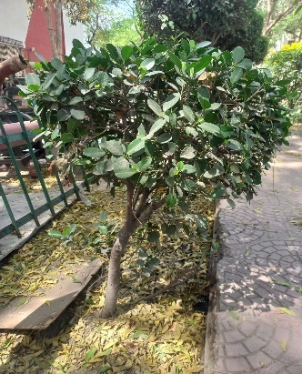

(a) *Ficus microcarpa* (b)*Hibiscus* sp.(c)*Alcea rosa* (d)*Tecoma stans*

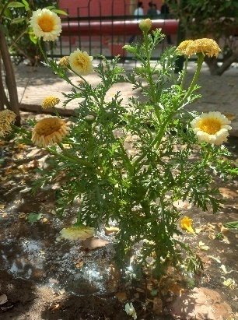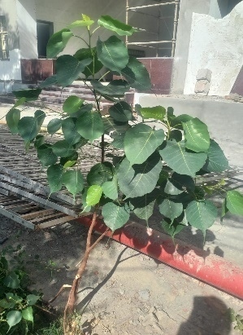

(e)*Glebionis coronaria* (f)*Ficus religiosa*

**Site D – Playground: Observational Report**

**Introduction**

The **Playground area** at J.C. Bose University of Science and Technology, YMCA (Site D), represents an ecologically important and multifunctional green space. Though primarily designed for student sports and recreation, the site incorporates a significant assemblage of **ornamental, shade-providing, and medicinally valuable plant species**. The presence of flora along the boundaries, walking tracks, and open soil patches contributes not only to the **aesthetic and environmental value** of the campus but also to biodiversity conservation in an open, dynamic landscape.

This report catalogs and evaluates the plant diversity surrounding the playground area, emphasizing their **habit, ecological role, and potential applications**.

**Fig. 4:** Site D-Playground

**Habitat and Floristic Composition**

The floristic distribution around the playground shows a predominance of **tree species**, accompanied by a smaller number of **shrubs, climbers, and grasses**. Most of the identified taxa belong to the **angiosperms (both dicots and monocots)**. The plantings are strategically arranged to offer:

* **Shade** along walking perimeters and seating zones
* **Soil stabilization and windbreak** near open field edges
* **Ornamental appeal** with flowering and foliage plants
* **Environmental services** such as carbon sequestration and pollution buffering

**Growth Habits Present:**

* **Trees**: *Ficus microcarpa*, *Cassia fistula*, *Tectona grandis*, *Syzygiumcumini*
* **Shrubs**: *Hibiscus rosa-sinensis*, *Durantaerecta*
* **Climbers**: *Bougainvillea spectabilis*, *Ficus pumila*
* **Grass/Herbaceous**: *Bambusa balcooa*, *Scrophularianingpoensis*

**Notable Observations**

**1. Shade and Canopy Species**

A variety of large canopy trees are planted to provide **shade for spectators and resting students**:

* *Ficus benghalensis* and *Ficus virens* exhibit expansive crowns and significant air-purifying capacity.
* *Terminalia catappa* and *Cocos nucifera* contribute to **sunlight filtration** and **heat regulation** in the field's open spaces.
* *Tectona grandis* (Teak) and *Grevillea robusta* (Silky Oak) offer dual roles as **ornamental and potential timber resources**.

**2. Ornamental and Landscape Plants**

Several flowering and foliage-rich species enhance the **visual appeal and spatial identity** of the playground:

* *Durantaerecta* and *Bougainvillea spectabilis* are used in **fence borders and hedge lines**, providing both color and structure.
* *Thunbergia erecta* and *Hibiscus rosa-sinensis* serve as seasonal floral attractions, beneficial for campus pollinators such as butterflies and bees.

**3. Medicinal and Ecologically Important Plants**

A number of species near the playground hold **medicinal or cultural significance**:

* *Saracaasoca* and *Phyllanthus emblica* offer traditional therapeutic value, especially for women’s health and immunity.
* *Pongamia pinnata* and *Albizia julibrissin* contribute to **soil enrichment via nitrogen fixation** and exhibit drought resistance.
* *Melia azedarach* and *Azadirachta indica* serve as **natural insect repellents**, particularly relevant for open-air recreational areas.

**4. Functional Climbing and Groundcover Species**

Climbers such as *Ficus pumila* and *Bougainvillea glabra* are trained along fences and pergolas, serving:

* **Aesthetic screening**
* **Microhabitat creation**
* **Wind buffering and dust reduction**

**Educational and Ecological Significance**

Although not an academic botanic garden, the playground flora serves several critical educational and ecological functions:

* **Plant identification and biodiversity awareness** opportunities for students during leisure or environmental study walks.
* Support for **local bird and insect biodiversity**, especially near flowering shrubs and fruiting trees.
* **Erosion control and ground cover** by species such as *Acacia auriculiformis* and *Bambusa balcooa*, which help manage stormwater runoff during rains.

The mix of **native species** like *Syzygiumcumini, Morius alba,* and *Cassia fistula* with **exotic ornamentals** like Grevillea robusta promotes **genetic diversity** and resilience in landscape vegetation.

Site D – the Playground – demonstrates a successful integration of **ecological design with recreational utility**. The diversity of tree and shrub species ensures that the space is not only functional for physical activity but also environmentally sustainable and visually pleasing.

|  |  |  |  |  |  |
| --- | --- | --- | --- | --- | --- |
| **S.No.** | **Botanical Name** | **Common Name** | **Family** | **Division** | **Habit** |
|  | *Ficus microcarpa* | Chinese Banyan | Moraceae | Angiosperms (Dicot) | Tree |
|  | *Durantaerecta* | Golden Dewdrop | Verbenaceae | Angiosperms (Dicot) | Shrub |
|  | *Thunbergia erecta* | Bush Clock Vine | Acanthaceae | Angiosperms (Dicot) | Shrub |
|  | *Bougainvillea spectabilis* | Bougainvillea | Nyctaginaceae | Angiosperms (Dicot) | Climber |
|  | *Siberian Elm* | Siberian Elm | Ulmaceae | Angiosperms (Dicot) | Tree |
|  | *Saracaasoca* | Ashok tree | Fabaceae | Angiosperms (Dicot) | Tree |
|  | *Melia azedarach* | Neem (Persian Lilac) | Meliaceae | Angiosperms (Dicot) | Tree |
|  | *Grevillea robusta* | Silky Oak | Proteaceae | Angiosperms (Dicot) | Tree |
|  | *Cocos nucifera* | Buddha Coconut Tree | Arecaceae | Angiosperms (Monocot) | Palm |
|  | *Ficus virens* | White Fig | Moraceae | Angiosperms (Dicot) | Tree |
|  | *Hibiscus rosa-sinensis* | China Rose | Malvaceae | Angiosperms (Dicot) | Shrub |
|  | *Ficus pumila* | Creeping Fig | Moraceae | Angiosperms (Dicot) | Climber |
|  | *Acacia auriculiformis* | Earleaf Acacia | Fabaceae | Angiosperms (Dicot) | Tree |
|  | *Bougaivillea glabra* | Lesser  Bougainvillea | Nyctaginaceae | Angiosperms (Dicot) | Shrub |
|  | *Albizia julibrissin* | Silk Tree | Fabaceae | Angiosperms (Dicot) | Tree |
|  | *Grevillea robusta* | Silky Oak | Proteaceae | Angiosperms (Dicot) | Tree |
|  | *Planchonelladuclitan* | Wild Cherry | Sapotaceae | Angiosperms (Dicot) | Tree |
|  | *Tectona grandis* | White Teak | Lamiaceae | Angiosperms (Dicot) | Tree |
|  | *Ficus benghalensis* | Banyan | Moraceae | Angiosperms (Dicot) | Tree |
|  | *Alstoniascholaris* | Blackboard Tree | Apocynaceae | Angiosperms (Dicot) | Tree |
|  | *Dalbergia sissoo* | Indian Rosewood (Shisham) | Fabaceae | Angiosperms (Dicot) | Tree |
|  | *Syzygiumcumini* | Jamun | Myrtaceae | Angiosperms (Dicot) | Tree |
|  | *Terminalia catappa* | Indian Almond | Combretaceae | Angiosperms (Dicot) | Tree |
|  | *Ficus religiosa* | Peepal | Moraceae | Angiosperms (Dicot) | Tree |
|  | *Scrophularianingpoensis* | Chinese Figwort | Scrophulariaceae | Angiosperms (Dicot) | Herb |
|  | *Phyllanthus emblica* | Amla | Phyllanthaceae | Angiosperms (Dicot) | Tree |
|  | *Morus alba* | White Mulberry | Moraceae | Angiosperms (Dicot) | Tree |
|  | *Mangifera indica* | Mango | Anacardiaceae | Angiosperms (Dicot) | Tree |
|  | *Cassia fistula* | Golden Shower Tree | Fabaceae | Angiosperms (Dicot) | Tree |
|  | *Bambusa balcooa* | Bamboo | Poaceae | Angiosperms (Monocot) | Grass |
|  | *Pongamia pinnata* | Indian Beech | Fabaceae | Angiosperms (Dicot) | Tree |

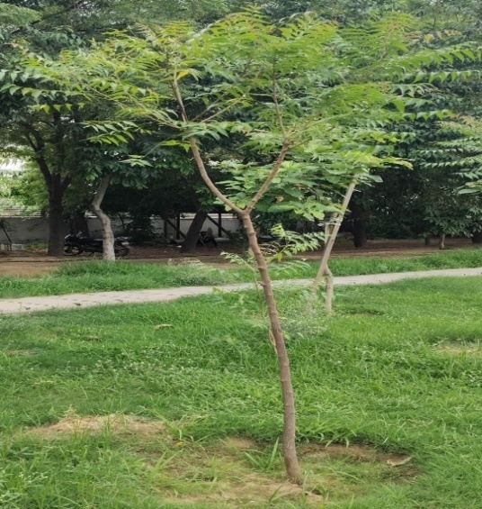

(a) *Azadirachta indica* (b) *Albizia julibrissim*

(c) *Ficus benghalensis* (d) *Syzygium cumini*

**RESULT**

In the dissertation work carried out the following sites were of focus :

SITE A: Nursery

SITE B: Greenhouse

SITE C: V.C. Office Park

SITE D: Playground

In the studied sited plants of various habits were observed i.e. shrubs, herbs, climbers, trees, grass. A pictorial representation of the same is given in following graphs:

**GRAPH 1: GRAPH SHOWING DIFFERENT HABIT SPECIES FOUND IN SITE A**

In site A plant species of tree habit were found to be maximum followed by herb, shrub and climbers respectively.

**GRAPH 2: GRAPH SHOWING DIFFERENT HABIT SPECIES FOUND IN SITE B**

In site B plant species of shrub habit were found to be maximum followed by tree, herb and climber respectively.

**GRAPH 3: GRAPH SHOWING DIFFERENT HABIT SPECIES FOUND IN SITE C**

In site C plant species of tree habit were found to be maximum followed by shrub and herb respectively.

**GRAPH 4: GRAPH SHOWING DIFFERENT HABIT SPECIES FOUND IN SITE D**

In site D plant species of tree habit were found to be maximum followed by shrub, climber respectively whereas grass and herb habit plants were found to be equal in number.

Furthermost, a compiled form of data was prepared for all 4 sites illustrating families and number of species found in these area of study.

**SITE A: NURSERY**

FAMILIES

No. of species found

**SITE B: GREENHOUSE**

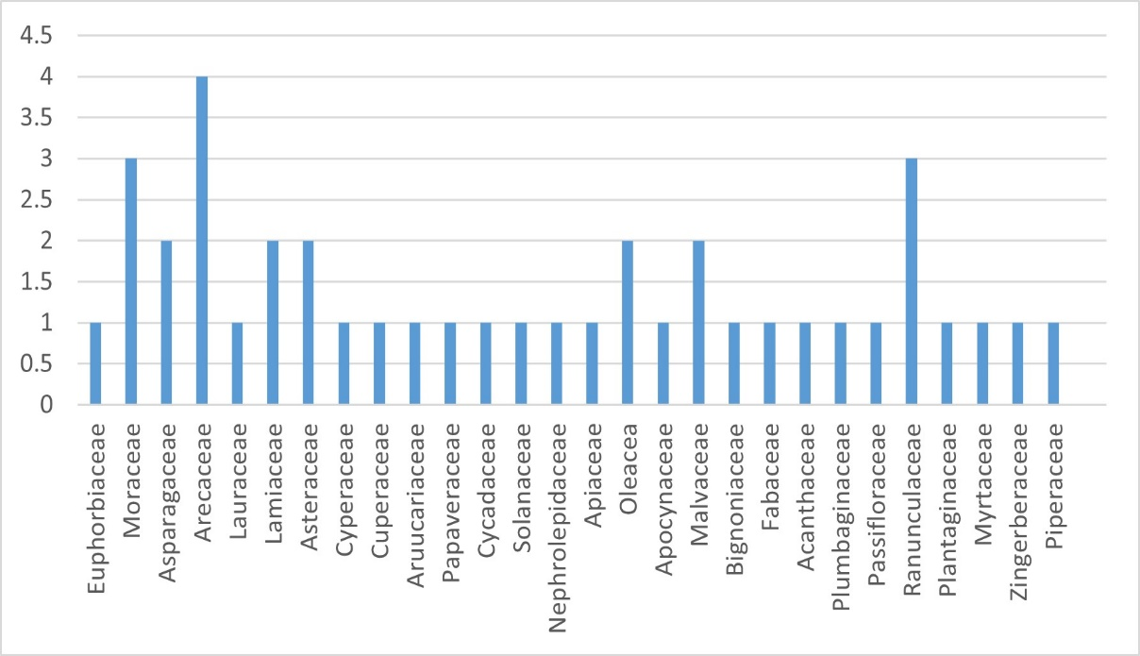

FAMILIES

No. of species found

**SITE C: V. C. OFFICE PARK**

No. of species found

FAMILIES

**SITE D: PLAYGROUND**

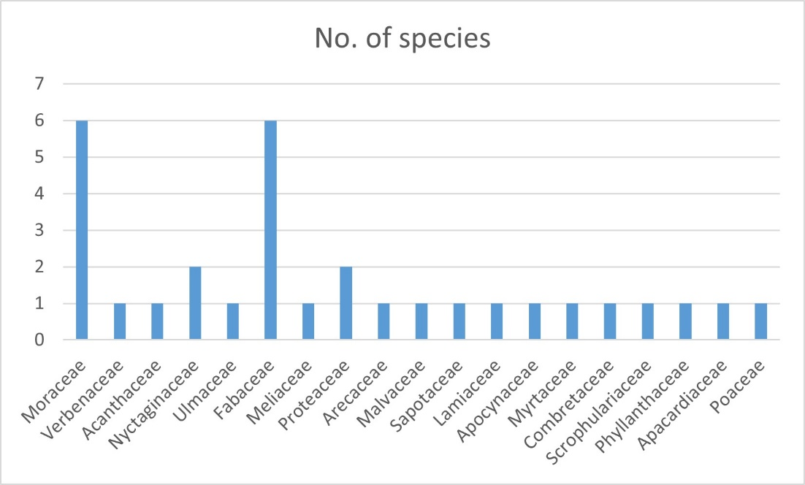

FAMILIES

No. of species found

**CONCLUSION**

The present dissertation work, aimed at studying the plant diversity within the campus of J. C. Bose University, has highlighted the ecological richness and biological significance of this academic environment. Through systematic field surveys and specimen identification, this study has documented a wide variety of plant species, spanning various families, habit forms, and ecological roles. The findings underscore the presence of a relatively high level of plant diversity within a confined urban-influenced setting, which is both encouraging and significant in the context of increasing anthropogenic pressures on natural ecosystems.

This investigation has revealed that the university campus serves as a vital green enclave, supporting a mix of native and introduced species, some of which hold medicinal, ornamental, and ecological importance. The presence of diverse flora—ranging from trees, shrubs, herbs, grasses, to climbers—not only enhances the aesthetic and environmental quality of the campus but also plays a critical role in supporting local biodiversity, including pollinators, birds, and soil microorganisms. The richness of species also reflects the variety of microhabitats and ecological niches present within the university's landscape.

In addition to cataloguing species, the research also brings to light the influence of campus management practices, infrastructure development, and seasonal variability on plant diversity patterns. It highlights the need for integrated and sustainable landscape planning that balances infrastructural growth with ecological preservation. In doing so, this study encourages a broader appreciation of green spaces in urban and semi-urban educational institutions—not merely as aesthetic elements, but as essential components of urban biodiversity and environmental sustainability.

Furthermore, the research serves as a foundational baseline for future ecological and conservation studies within the university. It opens avenues for more detailed investigations into plant-animal interactions, ecosystem services provided by campus flora, seasonal dynamics, and the potential impacts of climate change. Long-term monitoring and regular biodiversity audits are recommended to track changes over time and to inform adaptive conservation strategies.

Additionally, this study also carries educational value. By being involved in biodiversity documentation and awareness initiatives, the university can foster an environment of ecological consciousness and responsibility. Establishing botanical gardens, herbariums, or green clubs on campus could further this objective, transforming the university into not only a center of learning but also a steward of biodiversity conservation.

In conclusion, the study of plant diversity at J. C. Bose University reveals a promising ecological profile and emphasizes the importance of continued research, awareness, and proactive management. As urban landscapes continue to expand, institutions like J. C. Bose University have the unique opportunity—and responsibility—to lead by example in protecting and celebrating biodiversity within their realms. Through such efforts, they can contribute meaningfully to the global goals of **sustainability**, **conservation**, and **ecological education**.

**References**

1. Ford Foundation. (1998). *Forestry for sustainable rural development: A review of Ford Foundation supported community forestry programs in Asia*. Ford Foundation.
2. Treue, T. (2004). *History of community forestry* [Unpublished lecture notes]. The Royal Veterinary and Agricultural University.
3. McCarthey, J. (2004). Viewpoint – community forestry: A few sympathetic, but critical questions. *Bulletin of the Global Caucus on Community Based Forest Management*, *Fall*.
4. Chazdon, R. L. (2008). Beyond deforestation: Restoring forests and ecosystem services on degraded lands. *Science*, *320*(5882), 1458–1460.
5. Ranganathan, J., Daniels, R., Chandran, S., Ehrlich, P. R., & Daily, G. C. (2008). Sustaining biodiversity in ancient tropical countryside. *Proceedings of the National Academy of Sciences of the United States of America*, *105*(46), 17852–17854.
6. Sanderson, J. (2020). *Landscape ecology: A top down approach*. CRC Press.
7. Phillips, E. A. (1959). *Methods of vegetation study*. Henry Holt and Co.
8. Mishra, R. (1968). *Ecology workbook*. Oxford and IBH Publishing.
9. Curtis, J. T., & MacIntosh, R. P. (1951). An upland forest continuum in the prairie-forest border region of Wisconsin. *Ecology*, *32*, 476–498.
10. Raunkiaer, C. (1934). *The life forms of plants and statistical plant geography*. Clarendon Press.
11. National Remote Sensing Agency. (2008). *Biodiversity characterization at landscape level using remote sensing and geographic information system*. Department of Space, Government of India.
12. Shannon, C. E., & Wiener, W. (1963). *The mathematical theory of communication*. University of Illinois Press.
13. Simpson, E. H. (1949). The measurement of diversity. *Nature*, *163*, 688.
14. Pielou, E. C. (1966). The measurement of diversity in different types of biological collections. *Journal of Theoretical Biology*, *13*, 131–144.
15. Margalef, R. (1958). Information theory in ecology. *General Systematics*, *3*, 36–71.
16. Rout, S. K., & Gupta, S. R. (1989). Analysis of forest vegetation of Morni Hills in north-east Haryana. *Indian Academy of Science (Plant Science)*, *99*(2), 117–126.
17. Gupta, S. R., & Kumar, R. (2014). Vegetation composition and plant biodiversity in forest ecosystems of Siwaliks in northern Haryana. *Indian Journal of Fundamental and Applied Life Sciences*, *4*(2), 76–88.
18. Singh, V., Gupta, S. R., & Singh, N. (2014). Vegetation composition, species diversity and soil carbon storage in tropical dry deciduous forests of southern Haryana. *Indian Journal of Science*, *7*, 28–39.
19. Ewald, J. (2003). A critique for phytosociology. *Journal of Vegetation Science*, *14*, 291–296.
20. Kumar, A., Bajpai, O., Mishra, A. K., Sahu, N., Behera, S. K., Bargali, S. S., & Chaudhary, L. B. (2015). A checklist of the flowering plants of Katerniaghat Wildlife Sanctuary, Uttar Pradesh, India. *Journal of Threatened Taxa*, *7*(7), 7309–7348.
21. Rout, S. D., Panda, S. K., & Panda, T. (2018). Phytosociological and floristic evaluation of Kuldiha Wildlife Sanctuary, Odisha, India. *Tropical Plant Research*, *5*(3), 419–430.
22. Jaykumar, R., & Nair, K. K. N. (2012). Beta diversity of angiosperms in the tropical forests of Nilgiri Biosphere Reserve, India. *Tropical Ecology*, *53*(2), 125–164.
23. Barua, K. N., Gogoi, G., & Hazarika, P. (2018). Comparative study on structural composition and community association of Nambor Wildlife Sanctuary and its South-Westward extended Bornewria forest, Assam, India. *Tropical Plant Research*, *5*(2), 233–242.
24. Sahu, S. C., Dhal, N. K., & Mohanty, R. C. (2012). Tree species diversity, distribution and population structure in a tropical dry deciduous forest of Malygiri hill range, Eastern India. *Tropical Ecology*, *53*(2), 163–168.
25. Thakur, A. S. (2015). Floristic composition, life-forms and biological spectrum of tropical dry deciduous forest in Sagar Districts, Madhya Pradesh, India. *Tropical Plant Research*, *2*(2), 112–119.
26. Joshi, R. K., & Dhyani, S. (2019). Biomass, carbon density and diversity of tree species in tropical dry deciduous forests in Central India. *Acta Ecologica Sinica*, *39*(4), 289–299.
27. Kumar, M. L., Nag, A., Malakar, S., & Joshi, H. G. (2020). Population structure and diversity of trees in Amarkutir, a tropical dry deciduous forest of West Bengal, India. *Indian Journal of Ecology*, *47*(1), 150–154.
28. Suthari, S. (2013). *Biodiversity characterization and aboveground vegetation carbon pool assessment in Northern Telangana at landscape level using geospatial technique* [Doctoral dissertation, Kakatiya University].
29. Kumar, J. I. N., Kumar, R. N., Bhoi, R. K., & Sajish, P. R. (2010). Tree species diversity and soil nutrient status in three sites of tropical dry deciduous forest of western India. *Tropical Ecology*, *51*, 273–279.
30. Sundarapandian, S. M., & Swamy, P. S. (2000). Forest ecosystem structure and composition along an altitudinal gradient in the Western Ghats, South India. *Journal of Tropical Forest Science*, *12*, 104–123.
31. Verma, M. K., Niranjan, R. K., & Pal, A. (2015). Phytosociological attributes of a tropical dry deciduous forest of Bundelkhand region of Uttar Pradesh, India. *International Journal of Applied and Natural Sciences*, *3*(10), 86–99.
32. Panda, P. C., Mahapatra, A. K., Acharya, P. K., & Debata, A. K. (2013). Plant diversity in tropical deciduous forests of Eastern Ghats, India: A landscape level assessment. *International Journal of Biodiversity and Conservation*, *5*, 625–639.
33. Naidu, M. T., Premavani, D., Suthri, S., & Venkaiah, M. (2018). Assessment of tree diversity in tropical deciduous forests of Northcentral Eastern Ghats, India. Geology, Ecology, and Landscapes, 2(3), 216–227.
34. Lalfakawma, S. U. K., Roy, S., Vanlalhritpuia, K., & Vanlalhluna, P. C. (2009). Community composition and tree population structure in undisturbed and disturbed tropical semi-evergreen forest stands of North-East India. Applied Ecology and Environmental Research, 7, 303–318.
35. Agrawal, A. (2011). Effect of global warming on climate change, flora and fauna. Journal of Ecophysiology and Occupational Health, 11, 161–174.
36. Bonacorsi, N. K., Gensel, P. G., Hueber, N. F. M., Wellman, C. H., & Leslie, A. B. (2020). A novel reproductive strategy in an Early Devonian plant. Current Biology, 30(9), 388–389.
37. Diekmann, M., Kühne, A., & Isermann, M. (2007). Random vs. non-random sampling: Effects on patterns of species abundance, species richness, and vegetation-environment relationships. Folia Geobotanica, 42, 179–193.
38. Gaujour, E., Amiaud, B., Mignolet, C., & Plantureux, S. (2012). Factors and processes affecting plant biodiversity in permanent grasslands: A review. Agronomy for Sustainable Development, 32, 133–160.
39. Goswami, S. (n.d.). Preparing a herbarium: 8 steps. Biology Discussion.
40. Kenrick, P., & Crane, P. R. (1997). The origin and early evolution of plants on land. Nature, 389(6646), 33–39.
41. Köppen-Geiger climate classification of Kangra district. (n.d.). Climate-Data.org.
42. Le Bras, G., Pignal, M., Jeanson, M. L., Muller, S., Aupic, C., Carré, B., ... & Jabbour, F. (2017). The French Muséum national d’Histoire naturelle vascular plant herbarium collection dataset. Scientific Data, 4, 170016.
43. Mayer, H. A. (1953). Forest mensuration (183 pp.). Pennsylvania Valley Publisher.
44. Oseni, O. M., Pande, V., & Nailwal, T. K. (2018). A review on plant tissue culture: A technique for propagation and conservation of endangered plant species. International Journal of Current Microbiology and Applied Sciences, 7(7), 3778–3786.
45. Singh, S., Gautam, A., Sharma, A., & Batra, A. (2010). Centella asiatica (L.): A plant with immense medicinal potential but threatened. International Journal of Pharmaceutical Sciences Review and Research, 4(2), 9–17.
46. Sintayehu, D. W. (2018). Impact of climate change on biodiversity and associated key ecosystem services in Africa: A systematic review. Ecosystem Health and Sustainability, 4(9), 225–239.
47. Velásquez, A. C., Castroverde, C. D. M., & He, S. Y. (2019). Plant and pathogen warfare under changing climate conditions. Current Biology, 28(10), R619–R634.
48. Duthie, J. F. (1903-1922). Flora of the Upper Gangetic Plains and of the adjacent Siwalik and Sub-Himalayan Tracts. Govt. Press, Calcutta.
49. Jain, S. K. and R. R. Rao (1977). A Handbook of Field an Herbarium Methods. Today and Tommorrow’s Publishers, New Delhi.
50. Jain, S. P., D. M. Verma, S. C. Singh, J. S. Singh and S. Kumar (2000). Flora of Haryana. Central Institute of Medicinal and Aromatic Plants, Lucknow.
51. Maheshwari, J. K. (1963). The Flora of Delhi. Council of Scientific and Industrial Research, New Delhi.